Contents

List of Figure 2

Question 01 3

Code 3

Output 3

Question 02 3

Code 3

Output 3

Question 03 4

Code 4

Output 4

Question 04 4

Code 4

Output A 5

Output B 5

Output C 5

Question 05 5

Code 5

Output 6

# List of Figure

Figure 1: Q01 Output 3

Figure 2: Q02 Output 4

Figure 3: Q03 Output 4

Figure 4: Q04 A 5

Figure 5: A04 B 5

Figure 6: Q04 C 5

Figure 7: Q05 Output 6

# Question 01

## Code

clc

clear all

first=0;

second=1;

count=2;

fib=[first second];

while (count<20)

fib=[fib fib(count)+fib(count-1)]

count=count+1;

end

## Output

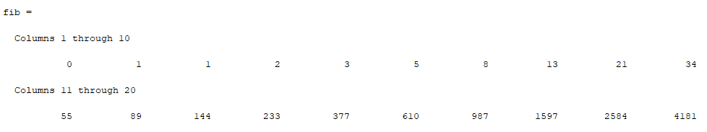

Figure : Q01 Output

# Question 02

## Code

clc

clear all

x=0;

sum_=0;

while (x<=5)

sum_=sum_+x;

x=x+1;

end

sum_

x

## Output

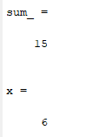

Figure : Q02 Output

# Question 03

## Code

clc

clear all

while (1)

x=input('Enter Postive value of x :');

if (x<0)

disp('You Enter the Negtive Number ')

elseif (x>0)

break

end

end

f=(3*cos(x)-sin(x))*exp(-0.2*x)

## Output

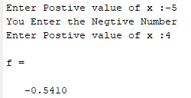

Figure : Q03 Output

# Question 04

## Code

clc

clear all

a=input('Enter the a :');

b=input('Enter the b :');

c=input('Enter the c :');

D=b^2 - 4*a*c;

Root1=(-b+sqrt(D))/(2*a);

Root2=(-b-sqrt(D))/(2*a);

if (D==0)

disp('The equation has one roots ')

Root1

elseif (D>0)

disp('The equation has two roots ')

Root1

Root2

elseif (D<0)

disp('The equation has no real roots ')

end

## Output A

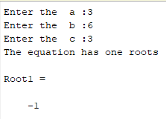

Figure : Q04 A

## Output B

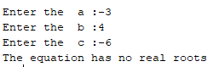

Figure : A04 B

## Output C

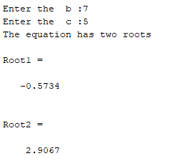

Figure : Q04 C

# Question 05

## Code

clc

clear all

r=randi([-10 10],1,20)

sum_=0;

for i=1:length(r)

if(r(i)>0)

sum_=sum_ + r(i);

end

end

sum_

## Output

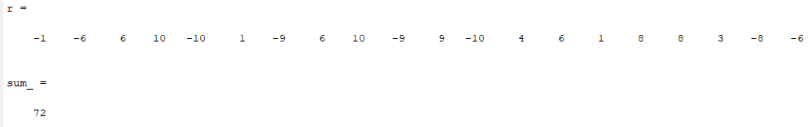

Figure : Q05 Output